PUBLIC HEARING NOTICE

CITY OF PAGE CITY COUNCIL
AND
PLANNING & ZONING COMMISSION

Pursuant to A.R.S. 9-461.06, NOTICE is hereby given to the members of the City of Page City Council, Planning & Zoning Commission, and to the general public that the City of Page Planning & Zoning Commission will hold a Public Hearing on August 6, 2024, at 5:30 P.M., and the City Council will hold a Public Hearing on August 21, 2024, at 5:30 P.M. (REVISED DATE) and both Public Hearings will be held in the City Council Chambers located at City Hall at 697 Vista Avenue, Page, AZ

The purpose of the Public Hearings is to gather information from the public and make a recommendation to the City Council regarding the following:

Minor Amendment to the Future Land Use Map (FLUM) of the Page 2040 General Plan required because the owners of Parcel No. 80114001V, M&S Cox Investments, LLC are requesting to change the zoning of said parcel from Planned Development Multi-Family Residential (PDRM) to Community Commercial (C-2) Zoning and the FLUM calls for the zoning of the property to be Multi-Family Residential. Parcel No. 80114001V is approximately 11.22 acres ± and located directly east of the Marriott Hotel on N. Lake Powell Boulevard and directly north of the City of Page Golf Course Driving Range, at the southeast corner of N. Lake Powell Boulevard and Clubhouse Drive. (See map & legal description below):

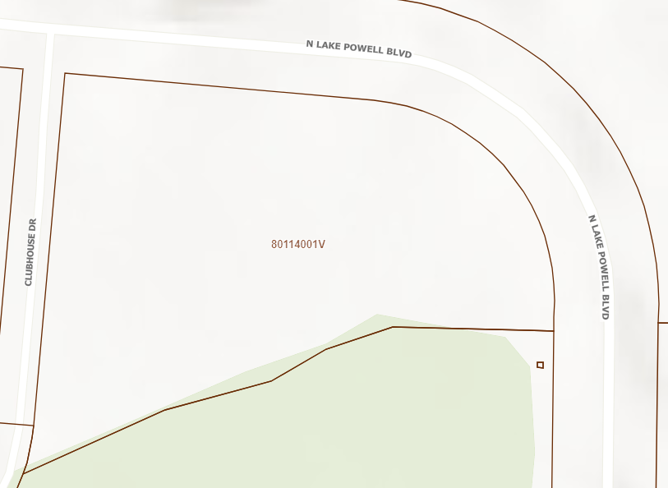
Minor Amendment to the General Plan FLUM – Subject Parcel No. 80114001V

The Legal Description of Parcel No. 80114001V, as further described below:

LOT 6A, AMENDED PLAT OF TRACT ELD 3, LOTS 5 & 6, SECTION 30, TOWNSHIP 41 NORTH, RANGE 9 EAST, G&SRM, COCONINO COUNTY, CITY OF PAGE, ARIZONA, CASE 6, MAP 97.

For more information about this Minor General Plan Amendment to the Future Land Use Map (FLUM) of the Page 2040 General Plan, the Public Hearing(s), or those individuals interested in commenting may appear in person or may submit written comments through the following contact:

Zach Montgomery, City Planning Director
City of Page Arizona
697 Vista Avenue
Page, AZ 86040
Phone: (928) 645-4261
Email: zmontgomery@pageaz.gov

Persons with disabilities who require special accommodations may contact Jennifer Lange, Deputy City Clerk at the above location or by calling (928) 645-4220 at least 48 hours before the Public Hearing.

Please publish the above Public Notice one (1) time in the July 31, 2024, edition of the newspaper.
This Ad must be published in a "display ad" covering not less than one-eighth of a full page.
Zach Montgomery, City Planning Director
(928) 645-4262 - zmontgomery@pageaz.gov

